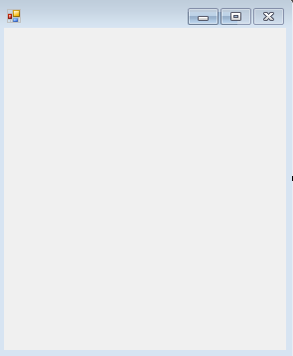

The character ‘,’ is an invalid input.

Username

Password

OK

Login





Incorrect username or password.



Browse

Backup File Path:

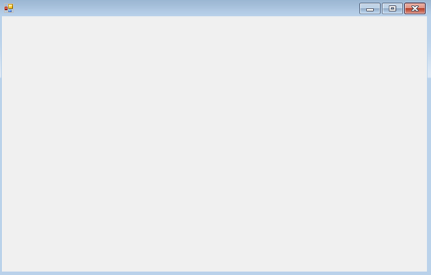

Tool Selection



Return Date

Take Out Date

Sale:

Tool Price (ex VAT)

Add new customer

Confirm

Customer on file?

Verify Customer

Customer Address

Customer Surname

Customer Forename

Final Price (ex VAT)

Final Price (inc VAT)

Confirm Transaction

Confirm Transaction:

Points to use in Transaction.

Points Gained on Transaction.

Current Customer Loyalty Points.

Loyalty Points:

Rental:

Name

Type

Category

Manufacturer

Tool ID

Verify/Add Customer

Customer Name

Price Algorithm

Image of tool.

Browse Tool



Mobile Number/ Contact number

Customer Address

Add Customer

Date of Birth

Customer Forename

Customer Surname



Current Tools:

New Damages:

Return

Customer Forename

Customer Address

Customer Surname



Transaction History



How much is each point worth?

Points earned per pound spent:

Loyalty Points

Rental Cost Algorithm

Percentage of base cost per day:

Flat Charge





Items added successfully.



OK

OK



Amend Details:

All Accounts:

JohnDoe42 ***** admin

_____________________________

New Username:

New Password:

Confirm



OK

Some input fields are empty.

Confirm and Add

Select Image

Quantity

Sale Price/Rental Cost

Rental

Sale

Name

Type

Category

Manufacturer



Confirm

Rental

New Image Path:

Sale

New Rental/Sale cost:

Rental Cost/Sale cost

New Name:

New Type:

New Category:

New Manufacturer:

Table of tools

Name

Type

Category

Manufacturer

Tool Number

Sort By:

For Rental

For Sale

Filters:



Generate Customer Statements

Customer details

View Transaction History

Return Tool

Browse Inventory

Customer Terminal:

Staff access:

Admin access:

Rental Price Algorithms

Backup and Archiving Settings

Amend Existing Accounts

Create Account

Customer Sale/Rental

Amend Items in Inventory

Add Items to Inventory

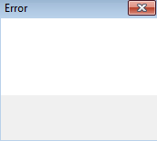

OK

OK

Account successfully created!

Invalid Account Information!

Create account

Security Level

Confirm Password

Password

Username